# Drawing Angles in Standard Position

Properly defining an angle first requires that we define a ray.

A **ray** is a directed line segment. It consists of one point on a line and all points extending in one direction from that point. The first point is called the endpoint of the ray. We can refer to a specific ray by stating its endpoint and any other point on it.

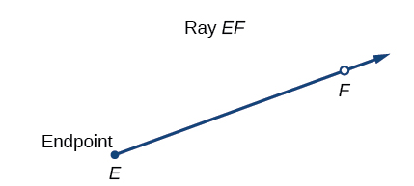

In symbolic form, we write $\vec{EF}$.

An **angle** is the union of two rays having a common endpoint, called the **vertex**.

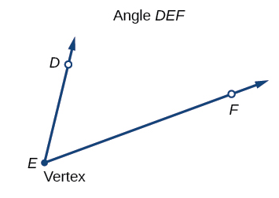

In symbolic form, we write $∠DEF$. Greek letters, such as theta $(θ)$, phi $(φ or ϕ)$, alpha $(α)$, beta $(β)$, and gamma $(γ)$ are commonly used to represent angles.

Although an angle can be drawn at any position and in any orientation in two-dimensional space, in trigonometry, it is often convenient to draw an angle on a coordinate plane.

When we draw the angle in what is known as **standard position**, we put its vertex at the origin, and we draw the **initial side** (the fixed ray) of the angle along the positive horizontal $x$-axis. Then we think of getting from the initial side of the angle to the **terminal side** (the rotated ray) of the angle by rotating the terminal side about the origin until it coincides with the initial side. The amount of that rotation corresponds to the measure of the angle. If the angle is measured in a counterclockwise direction from the initial side to the terminal side, the angle is said to be a **positive angle**. If the angle is measured in a clockwise direction, the angle is said to be a **negative angle**.

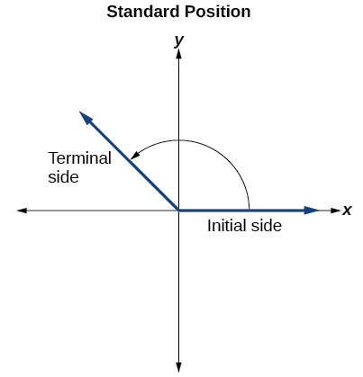

Remember, a full rotation gives $360°$. Angles whose terminal sides lie on an axis are quadrantal angles $(0°, 90°, 180°, 270°, or 360°)$.

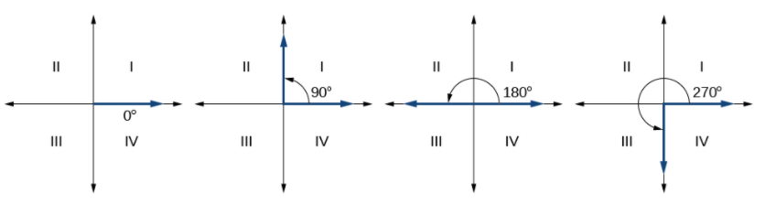

Examples: Draw each angle in standard position.

$240°$

$-45°$

# Converting Between Degrees and Radians

The circumference of a circle is $C=2πr$ . If we divide both sides of this equation by $r$ , we create the ratio of the circumference to the radius. So, the circumference of any circle is $2π$  times the length of the radius. That means that if we took a string as long as the radius and used it to measure consecutive lengths around the circumference, there would be room for six full string-lengths and a little more than a quarter of a seventh.

One **radian** is the measure of a central angle of a circle that intercepts an arc equal in length to the radius of that circle. A **central angle** is an angle formed at the center of a circle by two radii. Because the total circumference equals $2π$ times the radius, a full circular roation is $2π$ radians.

$2π$ radians = $360°$

$π$ radians = $\frac{360°}{2}=180°$

1 radian = $\frac{180°}{π}≈57.3°$

## Relating Arc Lengths to Radius

An arc length $s$ is the length of the curve along the arc. Just as the full circumference of a circle always has a constant ratio to the radius, the arc length produced by any given angle also has a constant relation to the radius, regardless of the length of the radius.

The **radian measure** of an angle is the ratio of the length of the arc subtended by the angle to the radius of the circle. In other words, if $s$ is the length of an arc of a circle, and $r$ is the radius of the circle, then the central angle containing that arc measures $\frac{s}{r}$ radians. In a circle of radius 1, the radian measure corresponds to the length of the arc.

Below are the most common radian measures in one rotation (along with the degree measures).

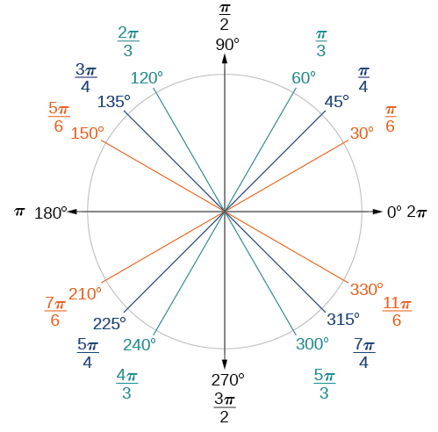

Examples:

1. Find the radian measure of one-third of a full rotation.
2. Find the radian measure of three-fourths of a full rotation.

## Converting Between Radians and Degrees

Because degrees and radians both measure angles, we need to be able to convert between them.

To convert between degrees and radians, use the proportion

$$\frac{\text{Degrees}}{180}=\frac{\text{Radians}}{π}$$

Examples:

1. Convert each radian measure to degrees.
 $\frac{π}{6}$

  1. 3
2. Convert each degree measure to radians.

$15°$

$126°$

# Finding Coterminal Angles

Negative angles and angles greater than a full revolution are more difficult to see on the circle than those in the range of $0°$  to $360°$ , or $0$  to $2π$ . It would be convenient to replace those out-of-range angles with a corresponding angle within the range of a single revolution.

It is possible for more than one angle to have the same terminal side. For instance, the angle below can be written as a positive angle $140°$ (going counter clockwise) or a negative angle $-220°$ (going clockwise).

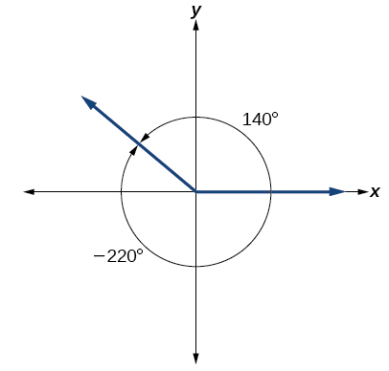

These angles are coterminal angles because they share the same terminal side. Any angle has infinitely many coterminal angles because each time we add $360°$ to that angle (or subtract $360°$), the resulting value has a terminal side in the same location. We can find coterminal angles measures in radians in the same way by adding/subtracting $2π$.

**Coterminal angles** are two angles in standard position that have the same terminal side.

Given an angle greater than $360° (2π)$ or less than $0°(0)$, we can find a coterminal angle between and by

1. Subtracting or Adding $360° (2π)$ from the given angle.

2. Repeat the subtracting or adding until the result is between $0°$ (0 radians) and .

3. Each of the resulting angles is coterminal with the original angle.

Examples: Find the least positive angle $θ$ that is coterminal with each angle below.

$870°$

$-300°$

$\frac{19π}{4}$

$-\frac{17π}{6}$

# Determining the Length of an Arc

In a circle of radius $r$, the length of an arc (or **arc length**) $s$ subtended by an angle with measure $θ$ in radians is

$$s=rθ$$

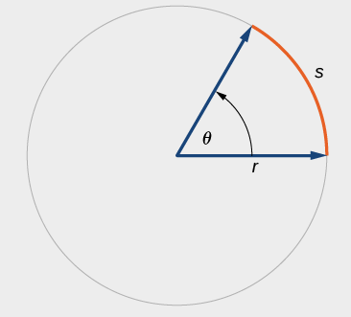

Examples:

1. Find the arc length along a circle of radius 10 units subtended by an angle of $215°$.
2. Find the length of the arc of a circle of radius 5.02 miles subtended by the central angle of $\frac{π}{4}$ radians.
3. Find the distance along an arc on the surface of Earth that subtends a central angle of 5 minutes $(1 \text{minute}=\frac{1}{60} \text{degree})$. The radius of Earth is 3960 miles.
4. Assume the orbit of Mercury around the sun is a perfect circle. Mercury is approximately 36 million miles from the sun.
   1. In one Earth day, Mercury completes 0.0114 of its total revolution. How many miles does it travel in one day?
   2. Use your answer from part (a) to determine the radian measure for Mercury’s movement in one Earth day.

# Finding the Area of a Sector of a Circle

In addition to arc length, we can also use angles to find the area of a sector of a circle.

The **area of a sector of a circle** with radius $r$ subtended by an angle $θ$, measured in radians, is

$$A=\frac{1}{2}θr^{2}$$

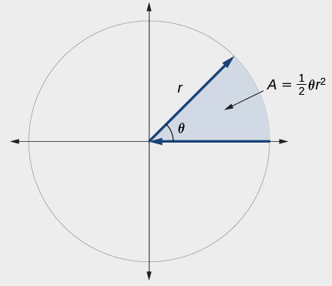

Examples:

1. Find the arc length and area of the sector shown below.

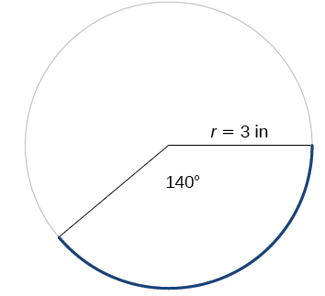

1. An automatic lawn sprinkler sprays a distance of 20 feet while rotating 30 degree, as shown in the figure below. What is the area of the sector of grass the sprinkler waters?

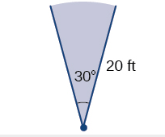

1. In central pivot irrigation, a large irrigation pipe on wheels rotates around a center point. A farmer has a central point system with a radius of 400 meters. If water restrictions only allow her to water 150 thousand square meters a day, what angle should she set the system to cover? Write the answer in radian measure to two decimal places.